Input Icons for TextMeshPro

**Requirements** (from package manager. Window 🡪 Package Manager):

* **TextMeshPro** **2.1.6 or higher**
* **Input System** **1.2.0** **or higher** (**1.3.0**, **1.4.4** or higher recommended)  
   (avoid 1.4.1, 1.4.2 and 1.4.3 as they produce errors on exiting play mode)

With Input Icons we can easily display current input bindings in TextMeshPro texts. Once set up, we can use the style tag of TMP (**<style=NameOfActionMap/NameOfAction>)** to display keyboard keys and gamepad controls inline with other texts. Since we use the style tag and we can update the default style sheet at runtime, we are able to update all TMP texts whenever we change the input device (e.g. if the player was using a keyboard and decides to switch to a gamepad). Additionally we can update the displayed sprites whenever we make changes to the input action bindings.

Included in this package are sprites for keyboard and mouse and sprites for XBox, PlayStation and Nintendo controllers. For any other controller, this system will display the sprites of the fallback Scriptable Object (this is set to XBox by default since most players on PC -according to Steam statistics - use XBox controllers).

Video guide: <https://youtu.be/pbm0UvPGCag>

**Overview**

Updating From An Earlier Version 2

Getting Started 3

Setting Up The Input Action Asset 4

Verifying Control Scheme Names 4

Adding Devices To Control Schemes 4

Quick Setup 5

Manual Setup 5

Using Different Sprites 5

Adding Or Updating Input Action Assets 6

IMPORTANT: Add Input Icons Activator Prefab to Scene 7

How To Use Input Icons 8

Displaying Input Bindings in TMPro 8

Keyboard And Gamepad Support 8

Stop Creating Player Inputs By Default 9

Rebind Buttons 9

Limitations 10

Customization 11

Adding Custom Context Sprites 11

Display Settings 11

Steam Integration 13

Troubleshooting 14

# Updating From An Earlier Version

When you update to a new version, you might experience missing input icons in your scenes. **Do the Quick Setup** in “**Tools🡪Input Icons Setup”** again and everything should be working as earlier. **Check** the path to the **“Default Sprite Assets folder”**, the “**Used Action Assets”** **list** and the **“Control Scheme Names”** at the top of the setup window or in the Input Icons Manager, as these values might have reset.

# Getting Started

To get started we can choose between using the sprites that come with this package or to use different sprites. Sprites for keyboard/mouse and controller sprites for Play Station, Steam, Nintendo Switch and Xbox are included and already set up in the package. Scriptable Objects which store the data for all our sprites are located in the Assets/InputIcons folder.

From the toolbar, open “**Tools/Input Icons Setup”**.

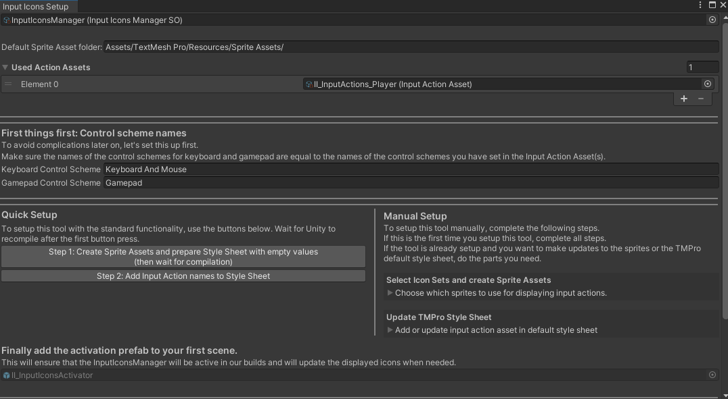

First we need an Input Action Asset containing our input actions. If we haven’t already, let’s head to the Package Manager (Window/Package Manager) and import the Input System package (this tool requires **Input System 1.2.0** or higher to save and load changes to the input bindings). Then create a new Input Action Asset and set up the Action Maps and Actions we need, or copy the one which comes with this package and adjust as needed. Add the Input Action Asset to the “Used Input Action Assets” list.

If you moved the TextMesh Pro folder to a different location, make sure to update the corresponding field in the setup window so the tool can create the required assets in the correct folders.

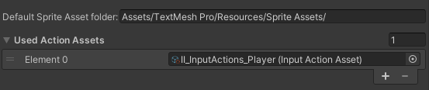

## Setting Up The Input Action Asset

Our Input Action Assets need control schemes for keyboard and gamepads. We have to add devices to the control schemes so the PlayerInput component can know which control schemes to use once we switch to gamepad or keyboard.

### Verifying Control Scheme Names

Let’s be sure that the Input Action Asset has **control schemes** set up **for keyboard and gamepad** control. Or only one of them, depending which device(s) we want to support. 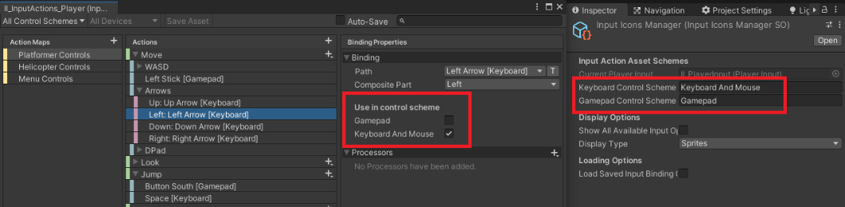

The InputIconsManager needs to know about these names. Fill in the names in the required fields in the setup window or in the InputIconsManager scriptable object.

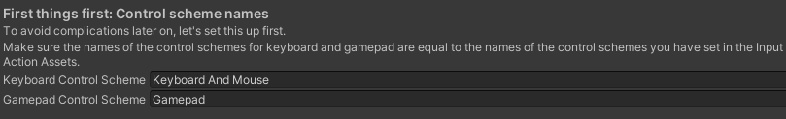

### Adding Devices To Control Schemes

We should now have two control schemes. One for gamepads, one for keyboard and mouse. We need to add devices to these control schemes in order for the PlayerInput component to know which control scheme to use when the user switches to a different device.

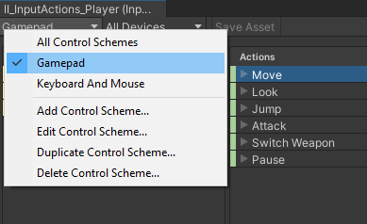 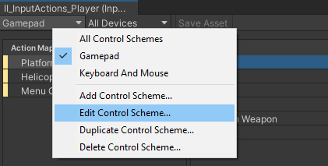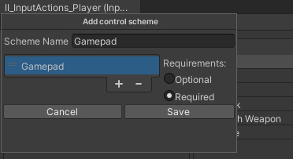

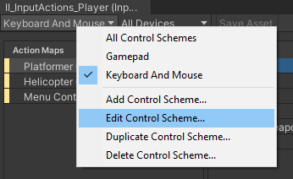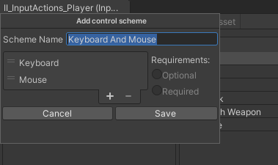

Once we have set up the Input Action Asset and the control scheme names + devices, we can continue with either the Quick Setup (recommended) or the Manual Setup which breaks up the setup process into smaller steps.

## Quick Setup

With the Input Icons Setup window opened (“**Tools/Input Icons Setup”** in the toolbar) we can use the buttons to setup Input Icons. These steps are here described in more detail.

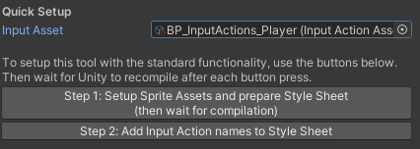**Step 1:** Once we have our Input Action Asset, we can start by creating Sprite Assets, filled with our keyboard and gamepad sprites. They will be placed in the default folder for Sprite Assets (usually “Assets/TextMesh Pro/Resources/Sprite Assets”). In the same step we can prepare the TMP Style Sheet by filling it with empty values which we can fill in the next step with the input action names of our Input Action Asset. (Unfortunately we can not insert the action names right away since we have limited access to the TMP Style Sheet – maybe this will change later but for now we have to do it this way.)

**Step 2**: After we have prepared the style sheet with empty entries, we can now insert the input action names of our Input Action Asset by pressing the second button.

Done! We can now display our binding icons by typing **<style=NameOfActionMap/NameOfAction>** (for example if we want to display the move controls for the platformer control scheme we would write **<style=Platformer Controls/Move>**). Once we start the game, the InputIconManager will update the default style sheet to display the sprites.

## Manual Setup

Open “**Tools/Input Icons Setup”** from the toolbar to find the custom setup section. This section comes in handy if at some point we

* decide to use a different set of sprites
* want to add more Input Action Assets to display more actions (be aware that action names must be different for each action we want to display as it only makes sense to save one instance of an action name into the default style sheet)

### Using Different Sprites

In the **Assets/InputIcons** **folder** are several **Scriptable Objects** which **store the sprites** used by the tool. There are 2 types of Scriptable Objects: one for keyboard sprites (InputIconSetKeyboardSO) and one for gamepad sprites (InputIconSetGamepadSO). To use a different set of sprites, other than the default ones, we can duplicate an IconSet and assign our wanted sprites to the new Scriptable Object. An efficient way of doing this is to drag the Scriptable Object into a folder containing our sprites and then click on **“Automatically apply button sprites of folder”** in the inspector of the Scriptable Object. The object will then try to assign as many sprites as possible (how well this works depends on the names of the sprites). For the “Custom Context” sprites, we have to apply the sprites manually as they can not be assigned automatically.

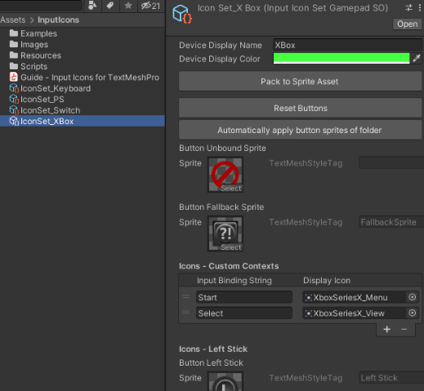 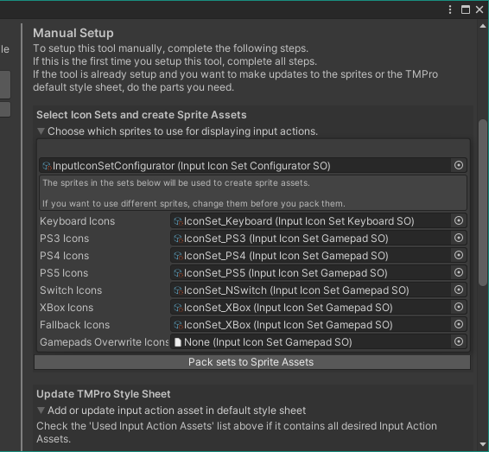

Once we have our Icon Sets ready, we can drag them into the **Manual Setup area of the Setup Window** and then hit the **“Pack sets to Sprite Assets”** button to create the necessary sprite assets in the default folder for Sprite Assets (usually “Assets/TextMesh Pro/Resources/Sprite Assets”). If we moved that folder, we have to let the tool know by updating the text appropriate text field at the top of the setup window.

Note that sometimes we will have to enter play mode or recompile for the new icons to be displayed.

### Adding Or Updating Input Action Assets

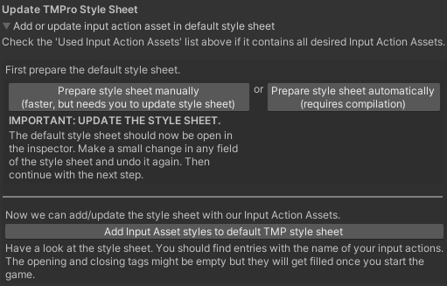We can use the Manual Setup section of the Input Icons Setup window to add and update entries in the TMP default style sheet. (but I would recommend to use only one Input Action Asset and add control schemes for various controls – e.g. control schemes for player controls and menu controls)

We have to prepare the style sheet, by adding empty values which can later be filled with the names of the action names in the Input Action Asset. In this section we have 2 buttons which basically fulfill the same purpose.

1. We can choose to use the first button (“Prepare Style Sheet manually”) and the empty values will be added. However, the Style Sheet Asset needs to updated/saved and the only way to do this for Style Sheets (at least the only way I found other than recompiling the project …) is to make a simple change in the inspector. So just adding a character to any field in the Style Sheet and removing it again is enough.
2. Using the second button (“Prepare Style Sheet automatically) will also add empty values and we don’t have to make manual changes to the style sheet, but Unity will have to compile and thereby save the changes made to the Style Sheet.

Now with the default style sheet prepared for the selected Input Action Asset, we can use the last button to write the action names into the style sheet.

## IMPORTANT: Add Input Icons Activator Prefab to Scene

It is important to know that Scriptable Objects only call their OnEnable methods when either being selected in the inspector or when being referenced by a MonoBehaviour or when being referenced by another Scriptable Object which is referenced.

Therefore the best way to ensure that the InputIconManagerSO (which is a Scriptable Object) works properly, is to reference it in the scene. We can easily do this by just dragging the **II_InputIconsActivator prefab** into the first scene.

# How To Use Input Icons

Lets make sure we have completed the setup:

1. The control scheme names of our Input Action Asset(s) match the names in the Input Icons Manager (found in **Assets/InputIcons/Resources/InputIcons**)
2. We have added the Input Action Assets we want to use to the list of used Input Action Assets in the setup window or in the Input Icons Manager Scriptable Object.
3. We created the Sprite Assets out of the Input Icon Sets and they are correctly stored in “**Assets/TextMesh Pro/Resources/Sprite Assets**” (if we moved the TMPro folder, this will be somewhere else)
4. We added the actions of our Input Action Asset(s) to the TMPro Style Sheet (“**Assets/TextMesh Pro/Resources/Style Sheets**”) (if we moved the TMPro folder, this will be somewhere else)

## Displaying Input Bindings in TMPro

Once we have completed the steps to setup Input Icons, we can display sprites related to our input actions by using the **TMPro-style tag (**[**http://digitalnativestudios.com/textmeshpro/docs/rich-text/#style**](http://digitalnativestudios.com/textmeshpro/docs/rich-text/#style)**)**.

Once we enter play mode, the opening tags of the styles in the style sheet should be filled with the corresponding tags to display the icons of the currently used device. This happens automatically through the Input Icons Manager.

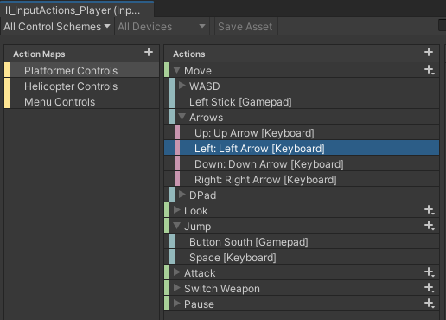We can use **<style=NameOfActionMap/NameOfAction>** inside a TMPro text field to show the bindings of an action.

To show the current binding for a jump action in the “Platform Controls” action map, we can write **<style=Platform Controls/Jump>** into a TMPro text field. Similar, for a move action we would write **<style=Platform Controls/Move>** and it would likely display “W A S D” or the arrow key sprites for keyboard input - or the left stick sprite if the user is using a gamepad.

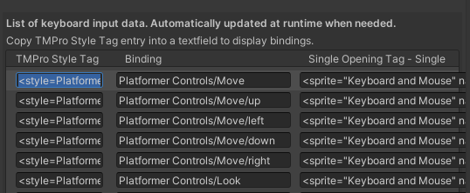If we don’t want to memorize all our action maps and bindings whenever we want to add a binding into a text field, we can open the Input Icons Manager and scroll down. There is a list available which stores all kinds of data used to display bindings. We can just copy and paste any entry in the first column (“TMPro Style Tag”) into a text field to display the correlated binding.

## Keyboard And Gamepad Support

To support keyboards and gamepads, our Input Action Asset(s) need to be correctly setup (see section “**Setting Up The Input Action Asset**”)

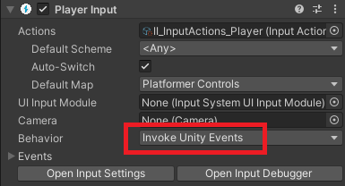The InputIconsManager will search for a **Player Input component** in the scene every time a new scene is loaded. If no such object is found, the manager will create an object by default when a new scene is loaded and will attach a Player Input component.  
The manager subscribes to the “Controls Changed Event” and will update the displayed icons every time the event fires. Therefore it is necessary that the behaviour of the PlayerInput component is set to “**Invoke Unity Events**”. If the behaviour is set to “**Send Messages**” or “**Broadcast Messages**”, a ”**InputIconsDeviceChangeDetection**”-script will be added to the gameobject which has the Player Input component. This script will listen for device changes and will call **InputIconsManagerSO.HandleControlsChanged(PlayerInput input)** when it detects a change. In case we use the “**Invoke C Sharp Events**” behaviour, we will have to call the above method manually to reflect changes to the current input device.

## Stop Creating Player Inputs By Default

As mentioned above, the Input Icons Manager will create an object and add a Player Input component when a new scene is loaded and the manager can not find a Player Input component in the scene hierarchy. This will ensure that the manager gets notified whenever the player switches devices, allowing the manager to update the displayed icons.

In some cases you might want to turn off this behavior, e.g. when you…

* load scenes additively containing your Player Input component
* instantiate a player prefab at runtime containing your Player Input component
* have a local multiplayer game and the Player Input Manager spawns prefabs containing a Player Input component per player
* … and more

To disable this behavior, select the InputIconsManager in Assets/InputIcons/Resources/InputIcons/ and tick off the checkbox **“Can create Player Input OnLevelLoaded”.** The manager will still try to find a Player Input component to subscribe to when a scene is loaded, but it will not create Player Inputs on its own anymore.

If you instantiate a Player Input component at runtime which the manager should listen to, make sure to call InputIconsManagerSO.SetCurrentPlayerInput(PlayerInput) so the manager can properly subscribe to the Controls Changed Event of the Player Input.

## Rebind Buttons

In the examples folder we can find the II_UI_RebindActionObject which is a prefab we can use to rebind our input. We might want to create our own prefab with custom visuals but this prefab is a good starting point. (I recommend to create another prefab out of this prefab so your buttons don’t get messed up when you update this asset)

The script takes an Input Action as a reference which we can then rebind by activating the button and then pressing the desired new key.

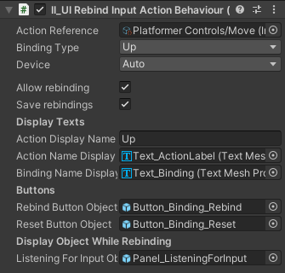For composite bindings, we need to select a Binding Type (Up, Down, Left, Right, Forward, Backward) in order to rebind the correct part of the action.

Device: We can select Auto, Keyboard and Mouse or Gamepad. When using Auto, the button will display keyboard icons when using the keyboard and gamepad icons when using the gamepad. The other options will always display either keyboard or gamepad icons and can only be rebound to the device specific bindings.

The toggle “Allow Rebinding” can be turned off for input actions we want to display to the player but which should not be rebound.

The toggle “Save rebindings” is turned on by default on all rebind buttons and will cause the overridden input mappings to be stored in the PlayerPrefs. Disabling this toggle will disable it on all rebind buttons.

The text field “Action Display Name” provides a quick way to change the text of the action name label without having to select the text object in the hierarchy.

## Limitations

* Supported keyboard layouts (with the exception of special characters) are **QWERTY**, **QWERTZ** and **AZERTY.** For all other keyboard layouts, the QWERTY layout (which is the most commonly used layout) will be used to display action bindings.
* If we use more than one Input Action Asset, we should not use the same names for the action maps across these Input Action Assets. Doing so might cause the manager to override style strings in the TMPro Default Style Sheet.

# Customization

## Adding Custom Context Sprites

The preset Input Icon Sets that come with this package (in the folder **Assets/InputIcons/** )already have sprites defined for all common input keys, gamepad buttons and joysticks. In case we need more input controls, we can add them in the Custom Contexts list in the Input Icon Sets. We need the input binding string and a display icon, to add a new binding.

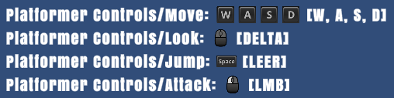An easy way to find the input binding string for an input is to use the script “II_UITextDisplayAllActions” which is in the example folder of this package. Add it to a TextMeshProUGUI object to display current input bindings. Then we can use a rebind button to override the current binding with the new binding we want to add. The input binding string for that binding will be displayed in the brackets. For the mousewheel, the input binding string would be “Scroll” for example.

**Important**: Whenever we make changes to an Input Icon Set, we will have to create a new Sprite Asset out of the Input Icon Set. Otherwise, our changes only exists in the Input Icon Set, but the desired sprite will not be available in the Sprite Asset used to display sprites within TMPro texts.

## Display Settings

The InputIconsManager provides options for how we want to display the input action bindings.

**Show All Available Input Option**: We can switch between showing only the first available binding, e.g. “WASD” or all available bindings, e.g. “WASD or Up Left Down Right” for a move action.

**Multiple Input Delimiter**: If we show all available options, we can define a delimiter between these actions. This delimiter can have TMPro tags for customization. The standard delimiter is “ <size=80%>or</size> “ and will therefore display a slightly smaller “or” between different bindings.

**Opening and Closing Tag**: Here we can add general styling options for the displayed icons. For example we can write <size=120%> in the opening tag and </size> into the closing tag to make all displayed icons a little bit bigger.

**Display Type**: input actions as sprites, text, or text in brackets.

**Text Display For Unbound Actions**: If we display bindings as Text or TextInBrackets, we can choose which text should be displayed for an unbound action.

**Text Display Language**: If we display bindings as Text or TextInBrackets, we can decide if we want to display this text in English or in System Language (the language currently used by the device, might produce very different results in text length and is generally not recommended).

**Action name output overrides**: If we use Text or TextInBrackets as the option to display input actions, we can override the text which would be displayed. For example it makes more sense to display [MOUSE] instead of [POSITION] for pointer controls.

# Steam Integration

Integrating the Steamworks.NET (<https://steamworks.github.io/>) into the project can cause some problems for the new Input System as Steam seems to literally hijack XInput. Therefore whenever we use steamworks we have to use some helper methods provided by steamworks in order to detect the currently used device. This is done in the script “InputIconsSteamworksExtensionSO” which will be active when we are using steamworks.

Fortunately, we don’t have to do a lot to support Input Icons in Steam, as the above mentioned script already handles the most important things for us. However, there are some limitations when playing via Steam. Since we use the Steam helper methods, it is more difficult to detect the currently used gamepad. For this reason Input Icons will display the used gamepad on index 0, which means that if we have a connected PS controller and a connected XBox controller, Input Icons will always display the first connected controller and the only way to display the other one is to disconnect one controller and restart the game.

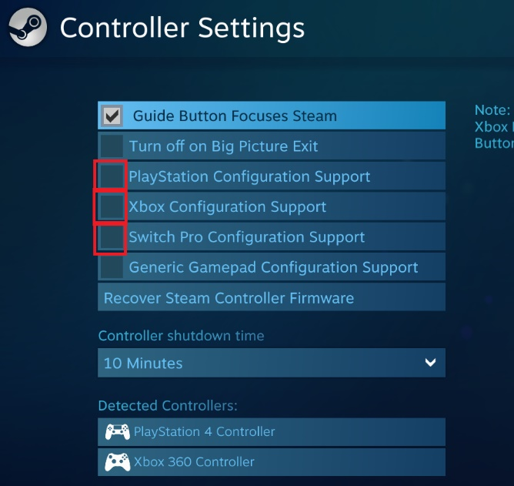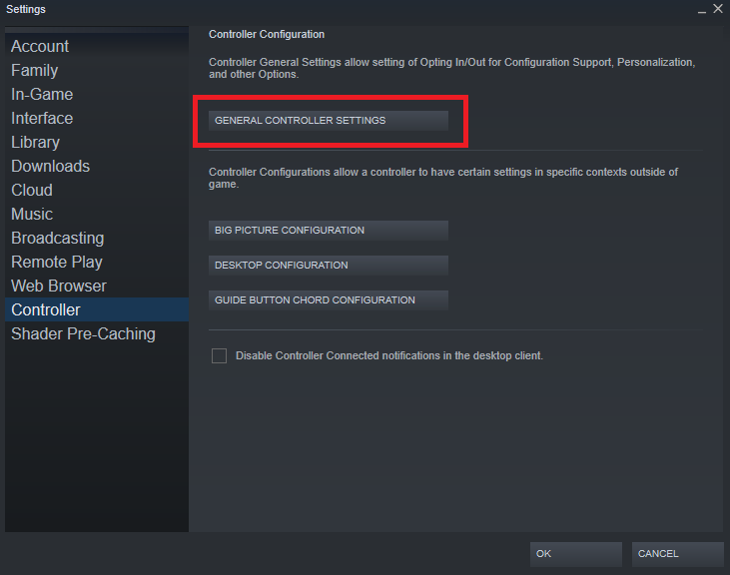Another issue that I noticed when developing for Steam is that the gamepads might sometimes not respond altogether. This can happen in the Unity editor or in a build when the editor or the build is run via Steam. A possible solution is to go into the Steam launcher and go to Steam -> Settings -> Controller -> General Controller Settings and disabling the Configuration Support for PlayStation, Xbox and Switch Pro. Then restart Unity or the game. By doing this, Unity’s Input System will regain control and the checks for the current device will work the as if we were not using Steam. Of course we can not expect players to go into these settings and disable them, but even if they are enabled, our games using Input Icons will still be able to display the correct keyboard and gamepad icons as long as users do not switch between different gamepad types (PS, XBox, Switch).

# Troubleshooting

Most problems appear from an incorrect setup. Remember, whenever you make changes to an Input Action Asset, to also update the style sheet by using the setup tool (Tools 🡪 Input Icons Setup).

If you have updated to a new version of Input Icons, the values in the InputIconsManager might very likely have changed. To solve this, do the Quick Setup again and everything should work again.

**Have our Sprite Assets been created correctly and does the TMPro Default Style Sheet contain our actions?**

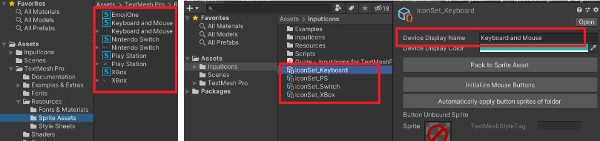

* **Sprite Assets**: In “Assets/TextMesh Pro/Resources/Sprite Assets/” we should find assets containing the sprites of the keys we want to display. It is important that these assets have the same names as the Icon Sets in “Assets/InputIcons/”.
* Ein Bild, das Text enthält.

  Automatisch generierte Beschreibung**TMPro Default Style Sheet**: The Default Style Sheet should somewhere contain the actions defined in our Input Action Assets. Check the style sheet in “Assets/TextMesh Pro/Resources/Style Sheets/”  
  **Special case**: The styles were added correctly, but **the styles disappear once we restart Unity** … the Default Style Sheet sometimes won’t save the changes. A workaround is to make a small change manually in any of the fields of the style sheet and then undo the change. This seems to work and the changes will be saved.

**If we don’t see any input icons**

* 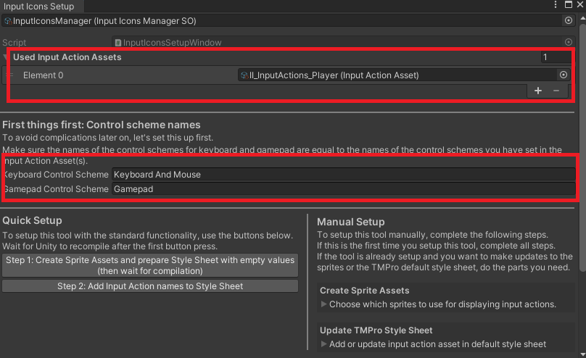The “**Used Input Action Assets**” list contains all Input Actions we use and we have updated the Default Style Sheet with all changes we made to the Input Action Asset(s).
* All our Input Action Assets have **control schemes for keyboard/gamepad** and their names are **equal to** the ones set in the Input Icons Setup or in the **Input Icons Manager** respectively.
* The **control schemes** of our Input Action Assets have **devices** added to them (see chapter “Adding Devices To Control Schemes”)

**Icons are shown, but don’t get updated when a different device is used:**

* Check section “**Keyboard And Gamepad Support**”
* 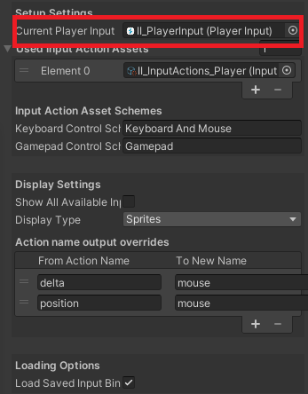Check the Input Icons Manager (in the folder “Assets/InputIcons/Resources/InputIcons/”. The “**Current Player Input**” field has a Player Input which is active in the scene.  
  Be aware that the Input Icons Manager will try to find an active Player Input component in the scene, whenever a scene is loaded and use it to handle changes of the active device. If you need to change to another Player Input within a scene, update the “Current Player Input” of the manager by calling InputIconsManagerSO.SetCurrentPlayerInput(PlayerInput input)

**Controls are weird or not working anymore**

* The reason might be that you have several active Player Input components in the scene. Search the hierarchy for “Player Input”.
* 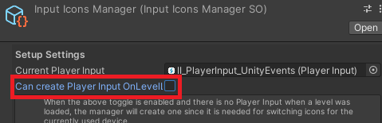If you load in Player Input components at runtime or by loading scenes additively, disable the “Can create Player Input OnLevelLoaded” option on the InputIconsManager. (see **Stop Creating Player Inputs By Default**)

If you have gone through this guide and still experience problems, feel free to contact me at [support@octacube-studios.com](mailto:support@octacube-studios.com)